PUZZLES OF CLEARING THE SPACE

1. White mates/ Black mates
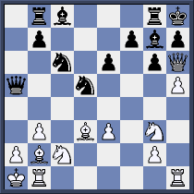

W:

B:

2. White mates/ Black wins
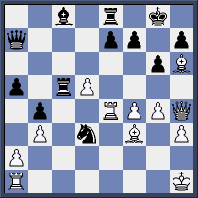

W:

B:

3. White mates/ Black mates
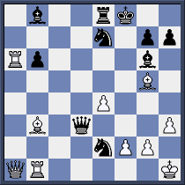

W:

B:

4. White mates/ Black mates
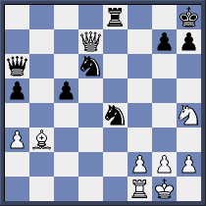

W:

B:

5. White wins/ Black wins
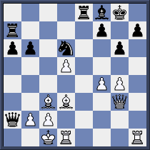

W:

B:

6. White mates/ Black mates
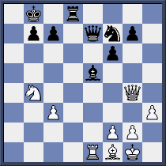

W:

B:

7. White wins/ Black mates

W:

B:

8. White mates/ Black wins

W:

B:

